* What are the various elements of the Excel interface? Describe how they're used.

There are  menu bar and contain a File, Insert, Page Layout, Formulas, Data, Review, View, Help, power pivot and a Search Bar with a light bulb icon . inside ribbons there are sub categories of different groups in groups there are sub categories of different icons.

2. Write down the various applications of Excel in the industry.

* Data entry.
* Data management.
* Accounting.
* Financial analysis.
* Charting and graphing.
* Programming.
* Time management.
* Task management.
* On the ribbon, make a new tab. Add some different groups, insert commands in the groups and name them according to their commands added. Copy and paste the screenshot of the steps you followed.

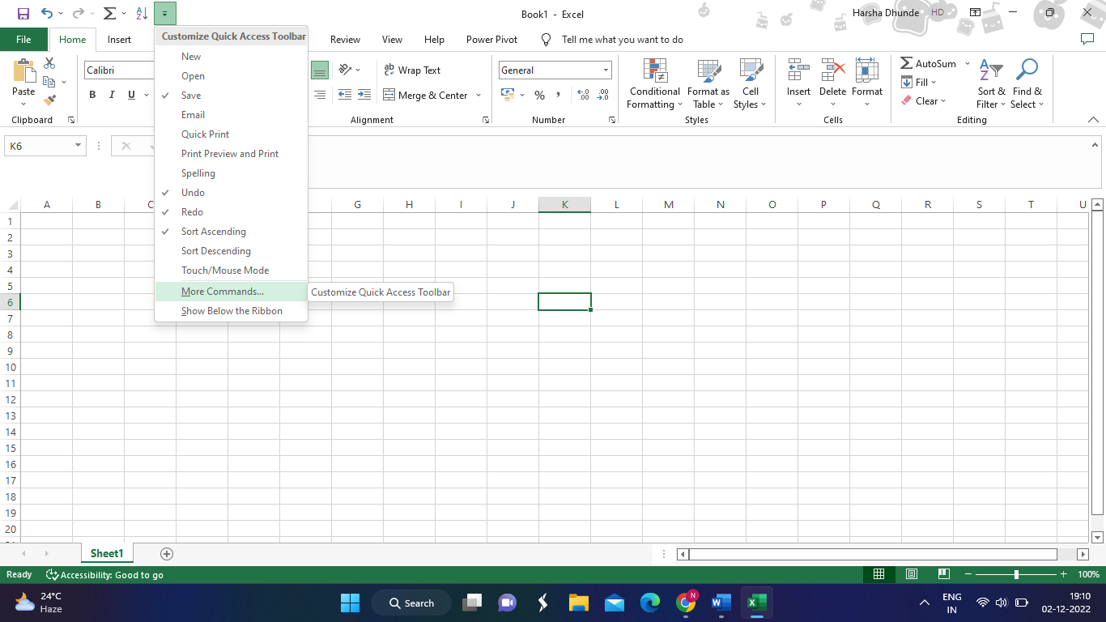

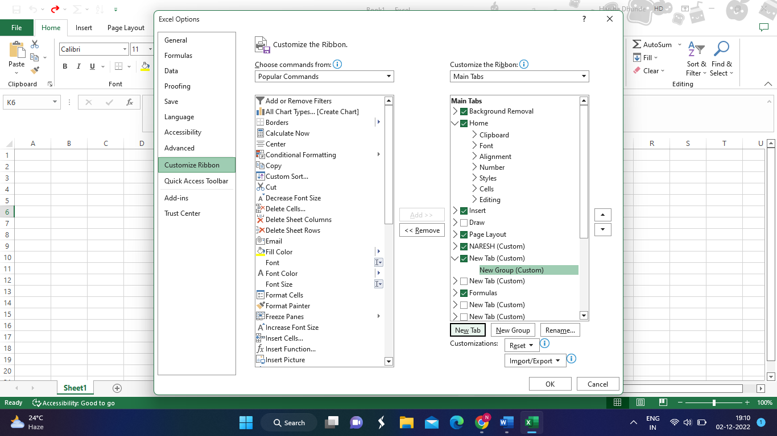

Tab created

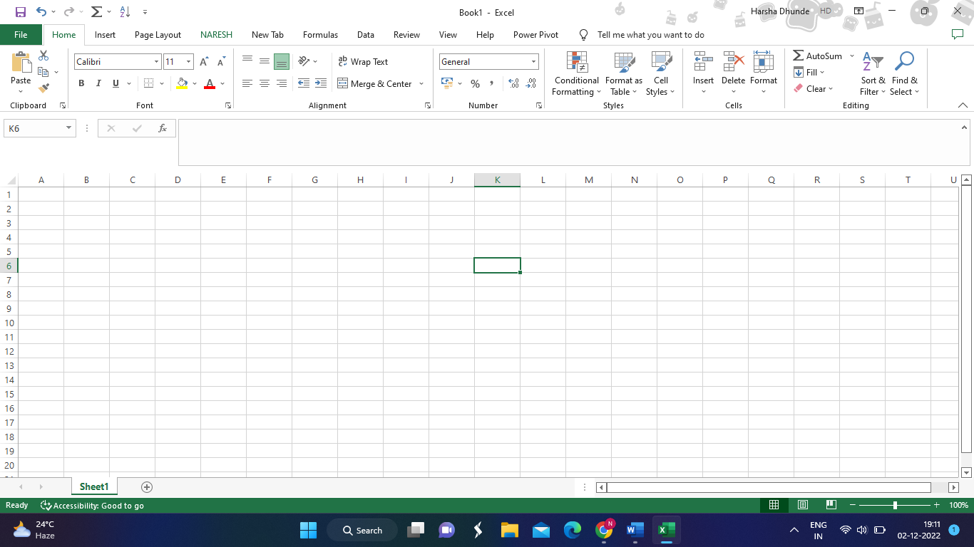

* 1. Make a list of different shortcut keys that are only connected to formatting with their functions.
* *Ctrl + C for Copy selected text or graphics*
* *Ctrl + V for Paste*
* *Ctrl+ Shift + A for Format all letters as capitals.*
* *Ctr l+ B → Applies or removes bold formatting.*

5. What distinguishes Excel from other analytical tools?

* It’s easy to get started with Excel.
* The learning resources are very rich.
* we can do a lot of things with Excel: modeling, visualization, reports, dynamic charts, etc.
* It also help understand the meaning of many operations before further learning other tools (such as Python and R).

6. Create a table and add a custom header and footer to your table.

